Bioinformatics Tasks – CodeAlpha (1 Month Internship in Bioinformatics)
Task 3: Protein Structure Prediction & Visualization
Protein: Myoglobin | Organism: Homo sapiens | Accession: P02144
Source Database: UniProt | Analysis Tool: AlphaFold / PyMOL / SWISS-MODEL

1. Background & Introduction

  - What is Myoglobin?

Myoglobin (Mb) is a small, monomeric, heme-containing protein found predominantly in the cardiac and skeletal muscle cells of vertebrates. It is a member of the globin superfamily and serves as the primary intracellular oxygen-storage protein in muscle tissue. By binding molecular oxygen reversibly via its heme prosthetic group, myoglobin acts as an oxygen reservoir that supplies O₂ to mitochondria during periods of intense muscular activity when demand exceeds the supply from blood hemoglobin.

Beyond oxygen storage, myoglobin also plays roles in facilitating oxygen diffusion within cells, buffering nitric oxide (NO) to regulate vascular tone, and acting as a reactive oxygen species (ROS) scavenger during ischemia-reperfusion events. Its characteristic red-brown pigmentation is responsible for the color of muscle tissue. In humans, the myoglobin gene (MB) is located on chromosome 22q12 and encodes a 154 amino acid polypeptide. Because of its well-defined tertiary structure — the classic “globin fold” of eight alpha-helices (A through H) — myoglobin was the first protein to have its three-dimensional structure solved by X-ray crystallography making it a landmark model in structural biology and bioinformatics.

2. Protein Identity

Field | Details
Protein Name | Myoglobin
Gene Symbol | MB
Organism | Homo sapiens (Human)
UniProt Accession | P02144
Entry Name | MYG_HUMAN
Sequence Length | 154 amino acids

3. FASTA Sequence

>sp|P02144|MYG_HUMAN Myoglobin OS=Homo sapiens OX=9606 GN=MB PE=1 SV=1
MGLSDGEWQLVLNVWGKVEADIPGHGQEVLIRLFKGHPETLEKFDKFKHLKSEDEMKASEDLKKHGATVLTALGGILKKKGHHEAEIKPLAQSHATKHKIPVKYLEFISECIIQVLQSKHPGDFGADAQGAMNKALELFRKDMASNYKELGFQG

4. PDB Structure – 3RGK

The experimental crystal structure of human Myoglobin is available in the Protein Data Bank as entry 3RGK (X-ray diffraction, 1.65Å resolution). This structure was used as the basis for molecular visualization in UCSF Chimera.

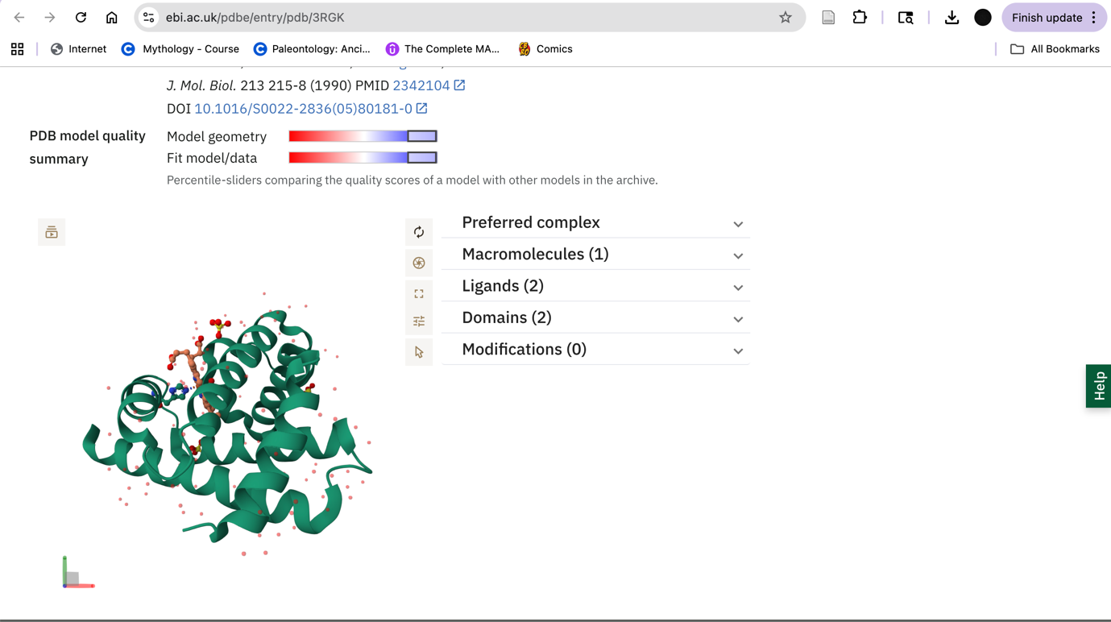
Figure 1: PDB entry 3RGK – Crystal Structure of Human Myoglobin (X-ray diffraction, 1.65Å resolution)
5. Visualization with UCSF Chimera

The 3D structure of Myoglobin (PDB: 3RGK) was loaded and visualized using UCSF Chimera. Two views were generated to illustrate the overall fold and the heme-binding site.
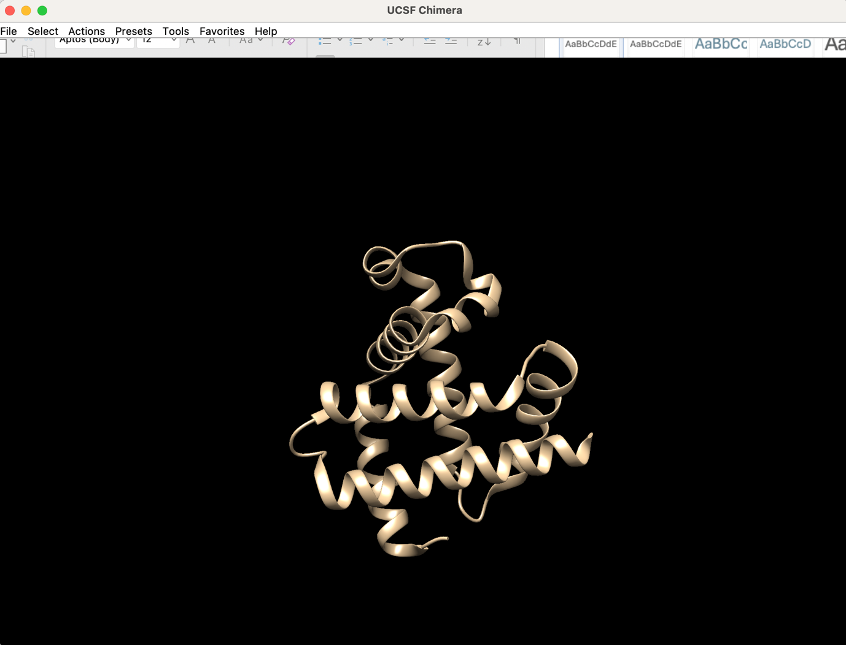
Figure 2: UCSF Chimera – Ribbon representation of Myoglobin showing the eight alpha-helices (A–H) of the globin fold (PDB: 3RGK)
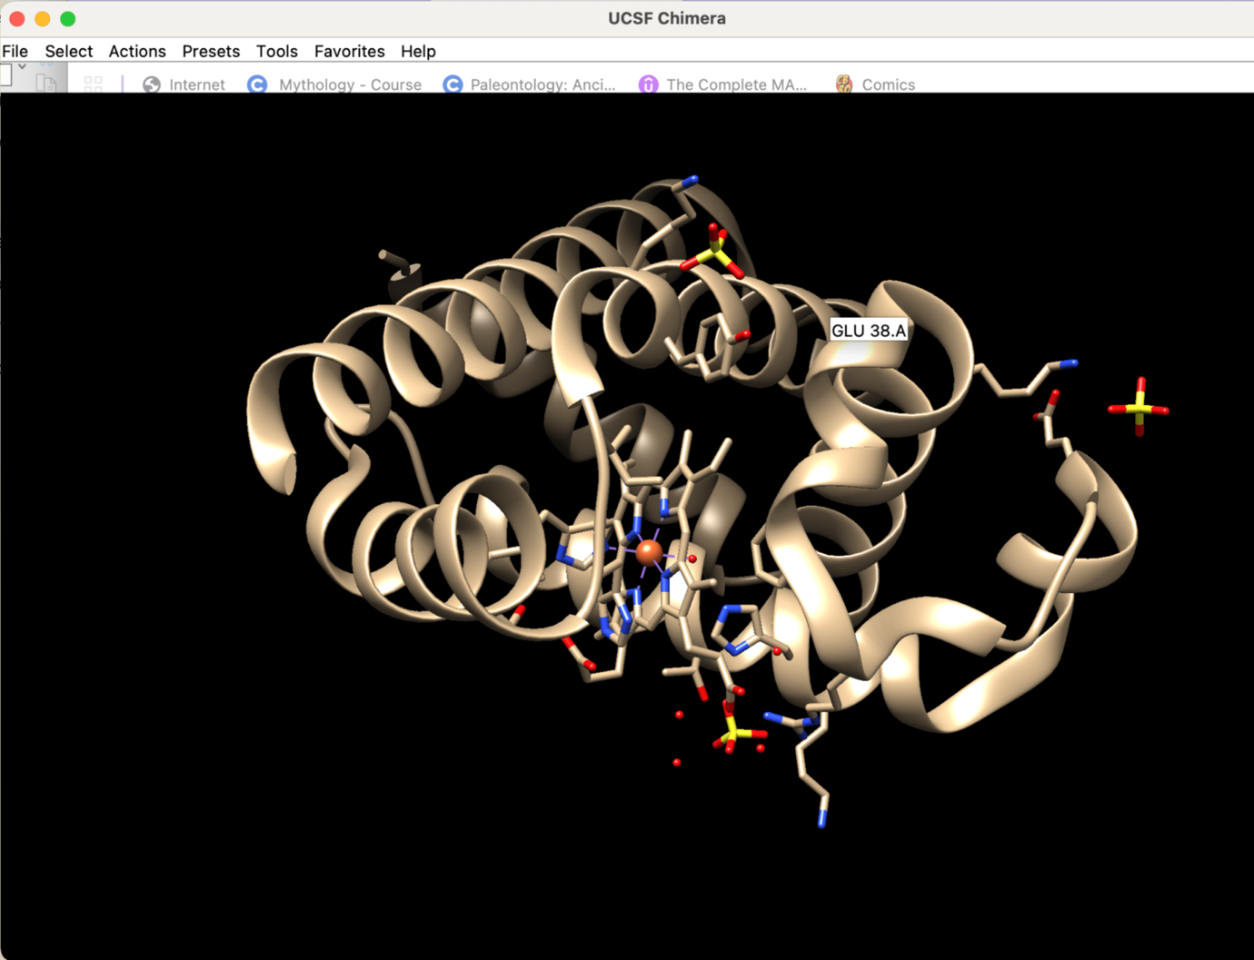
Figure 3: UCSF Chimera – Detailed view of the heme-binding pocket with key residues displayed. The heme iron (orange sphere) is coordinated by the proximal histidine (His93)
6. Secondary Structure Elements
Human Myoglobin contains eight alpha-helices (A–H) forming a compact globular domain. The table below summarizes each helix and its functional role:

Helix | Residues | Count | Function
A | 4–18 | 15 | N-terminal helix; contributes to heme environment
B | 20–35 | 16 | Packs against heme propionate groups
C | 36–42 | 7 | Short helix; connects B and CD loop
D | 51–57 | 7 | Positions key heme-binding residues
E | 58–77 | 20 | Contains His64 (distal His); critical for O₂ binding
F | 86–96 | 11 | Contains His93 (proximal His); linked to heme Fe
G | 100–118 | 19 | Hydrophobic core; stabilizes folding
H | 124–148 | 25 | C-terminal helix; longest in the structure

7. Key Functional Residues

- His93 (F8 – Proximal Histidine): Forms the fifth coordination bond to the heme iron (Fe²⁺), anchoring the heme. Conserved across all vertebrate myoglobins; mutation abolishes O₂ binding.
- His64 (E7 – Distal Histidine): Hydrogen bonds with bound O₂, stabilizing the oxy-form and reducing autoxidation. Discriminates O₂ from CO binding.
- Val68 (E11): Lines the oxygen-binding pocket; controls ligand access to the heme iron via steric gating.
- Phe43 (CD1): Contacts the heme vinyl group; essential for heme insertion and stable porphyrin ring positioning.

8. Conclusion

The structure of human Myoglobin (P02144, PDB: 3RGK) was successfully visualized using UCSF Chimera. The classic eight-helix globin fold cradles the heme prosthetic group, with His93 and His64 serving as the proximal and distal ligands for O₂ binding. The high-resolution crystal structure (1.65Å) confirms the precise geometry of the active site, consistent with myoglobin’s role as a muscle oxygen store.

